**Pre-requisite:**

Maven: Any version (apache-maven-3.6.3 used)

Java: Any version (jdk-11.0.6 used)

Browser: Chrome

Chrome Version: 81

ChromeDriver Version: 81

**Instructions:**

1. Clone the project to your local
2. Open cmd and go inside the project folder
3. Run command:

mvn clean

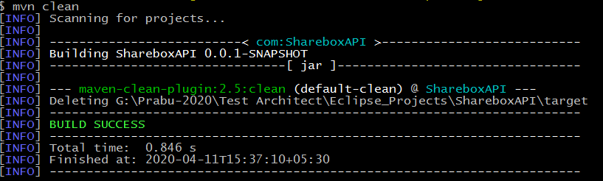

1. Run command:

mvn verify

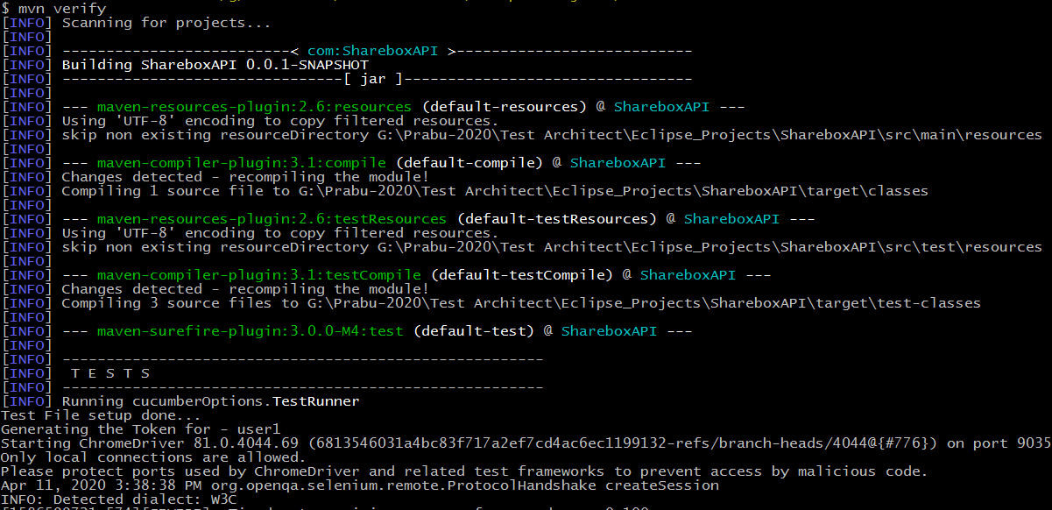

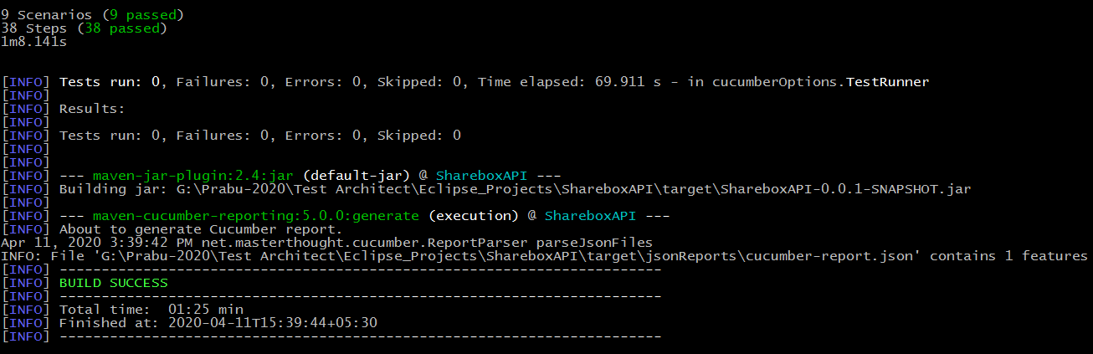

1. You can view the test reports under **target > cucumber-html-reports** inside the project

